29. Develop a system using UML for the s. The customer can create a login and the details are stored by the system. The customer can view the bus and seat availability from source to destination on a given date and time. The customer can book tickets and view the status of the bus. The customer can cancel the ticket and a refund will be decided based on the time remaining before the departure of the bus.

State Diagram :

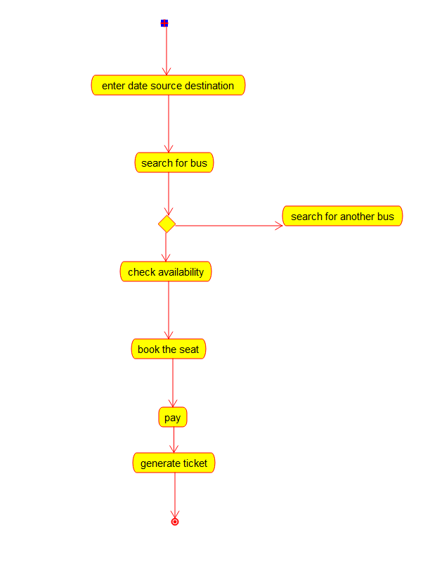

Component Diagram :

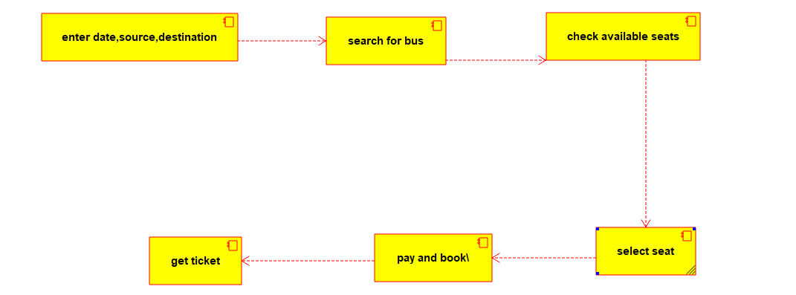

Sequence Diagram :

